Week 3 Exploratory Analysis:

* **Rachel Reich**



* **Elesha Hunter**



* **Kaity Tainer**

Exploratory Questions

1. What is the difference between the probability of interview selection versus the probability of actually being hired between men and women?
2. Is there a significant difference between the different types of degrees candidates have and their likelihood of being hired by NASA?
3. Is there a significant difference between how male and female bodies fare in space?

Tableau

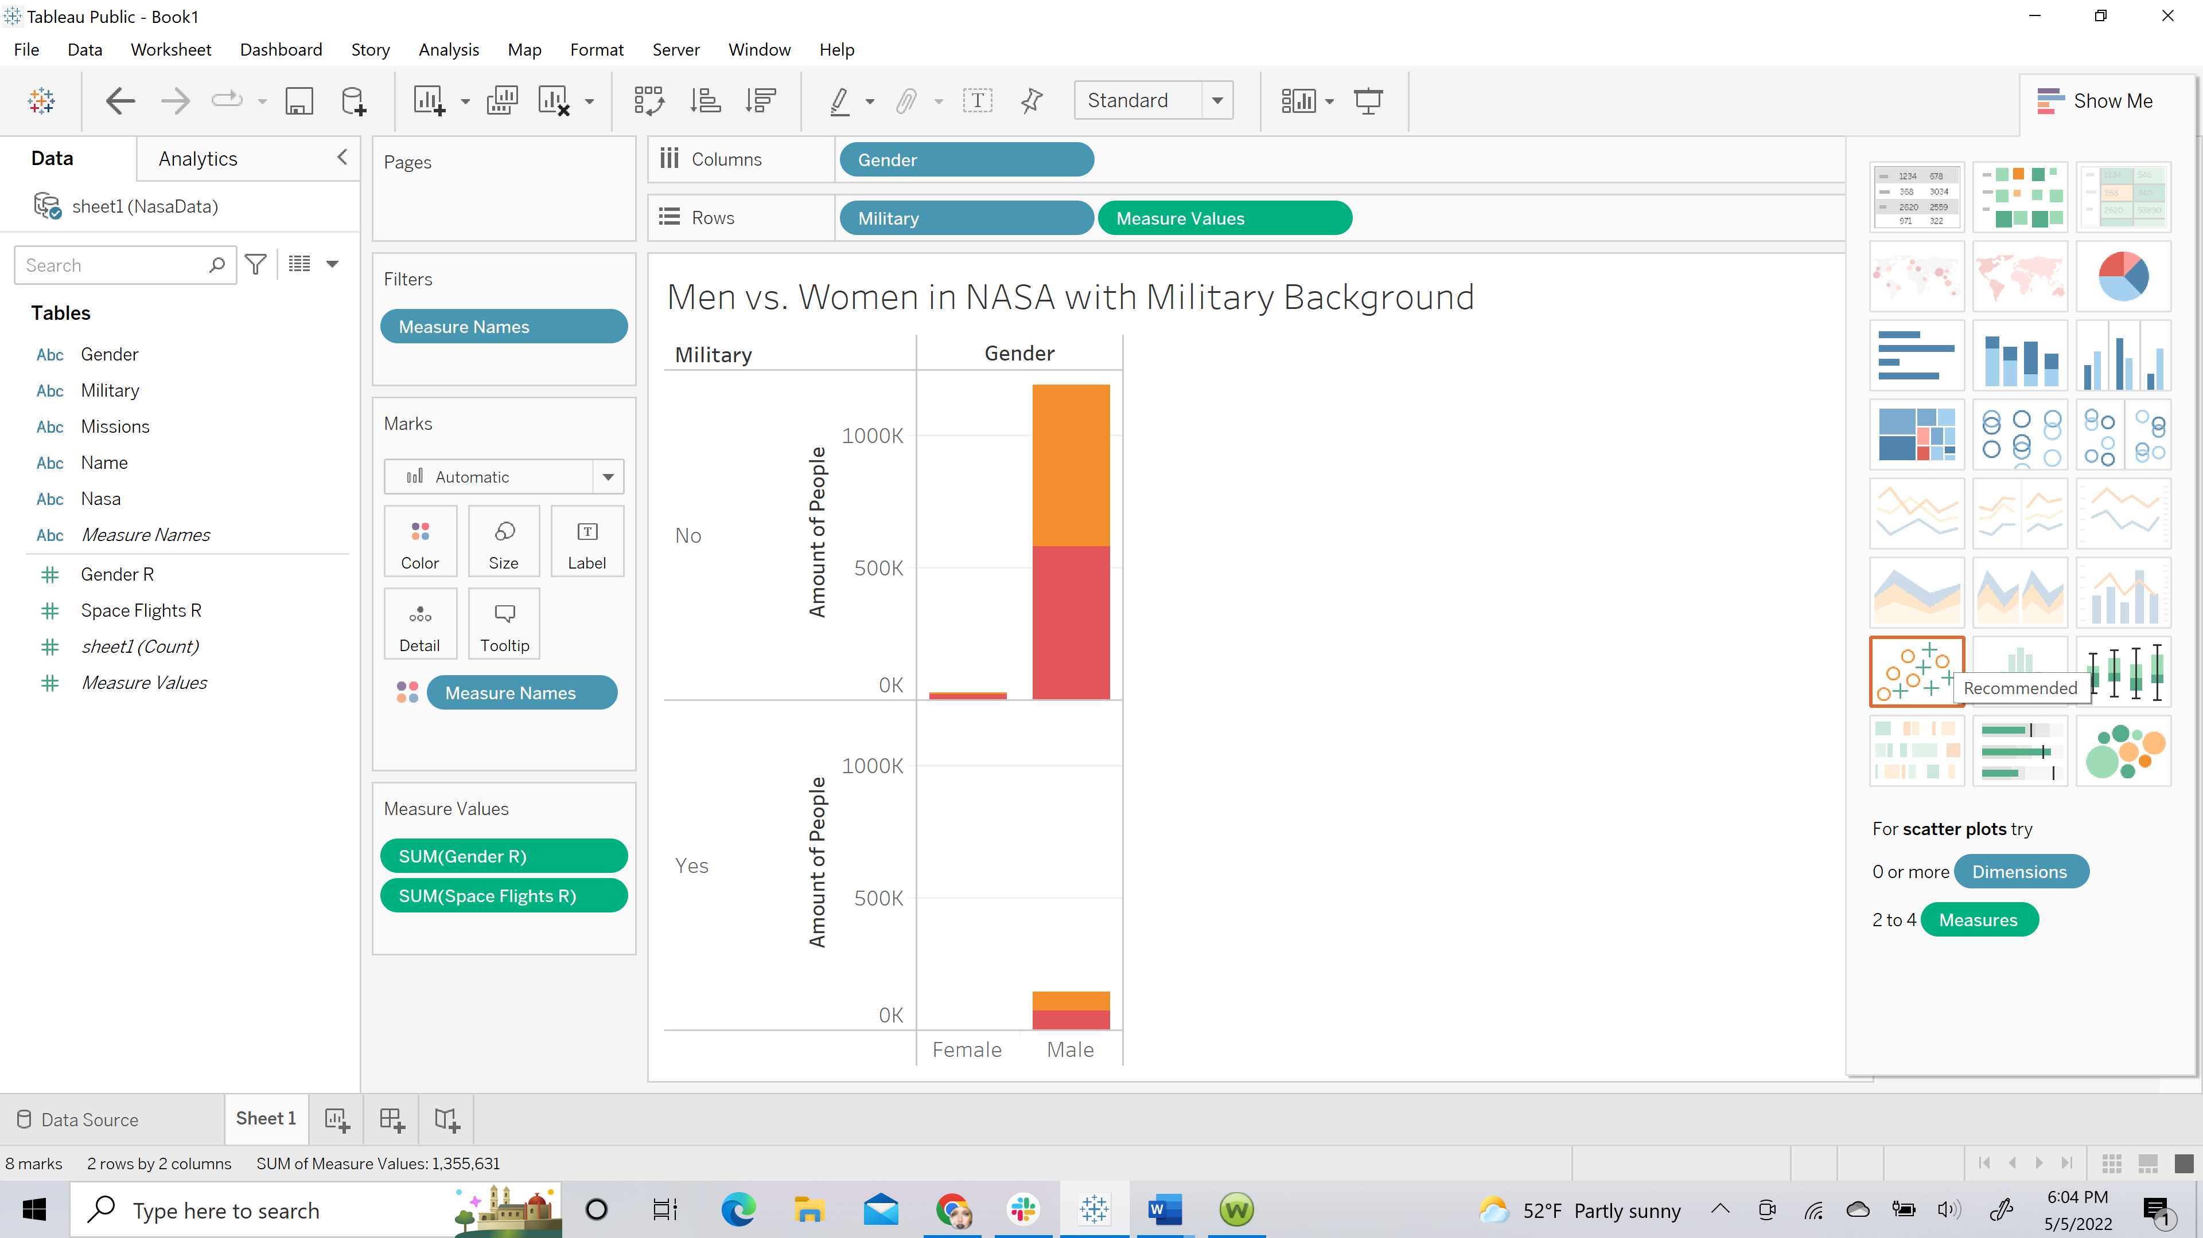

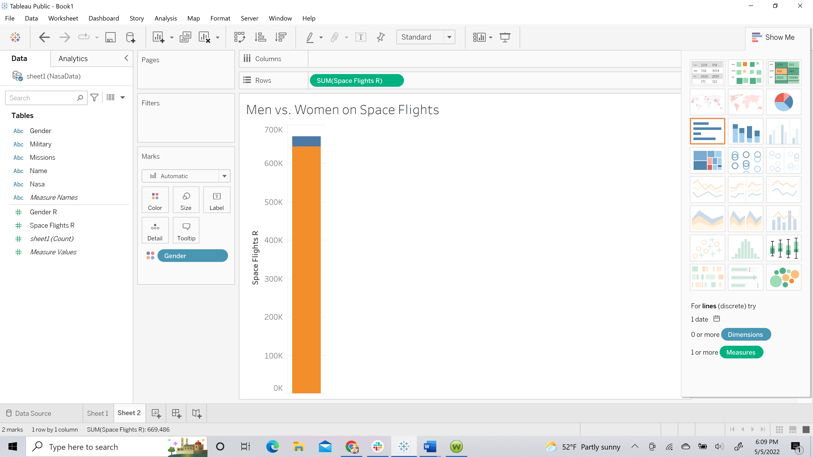

When hovered over, you can see the number of males (643,680) vs. females (25,806)

This specific dataset didn’t have a lot of different combinations to try from the tables provided, but had some basic information regarding the main topic of our project.

* Stacey Gonzalez

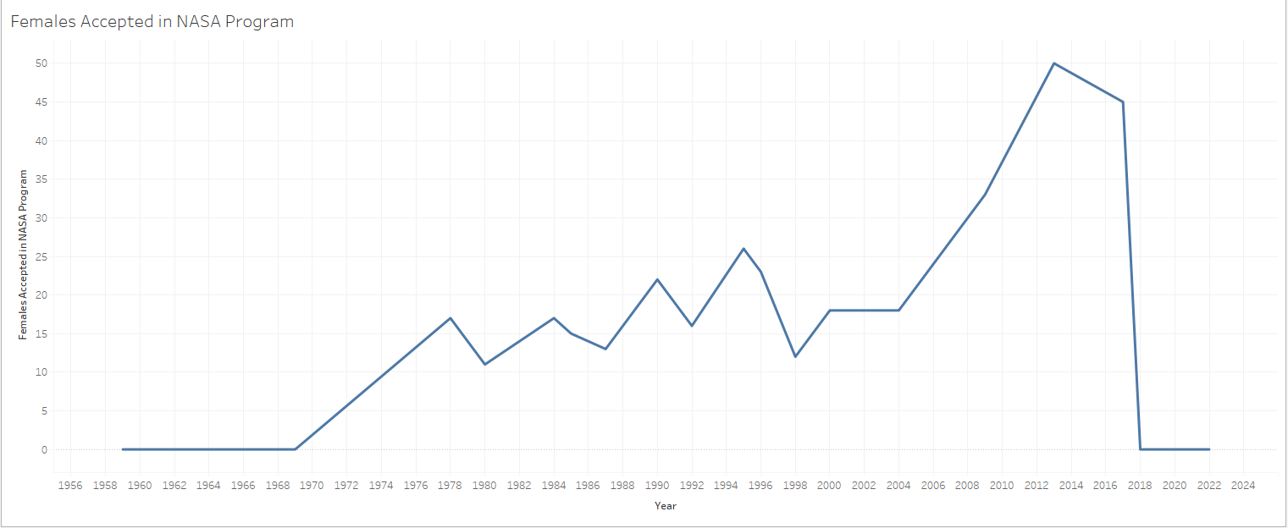

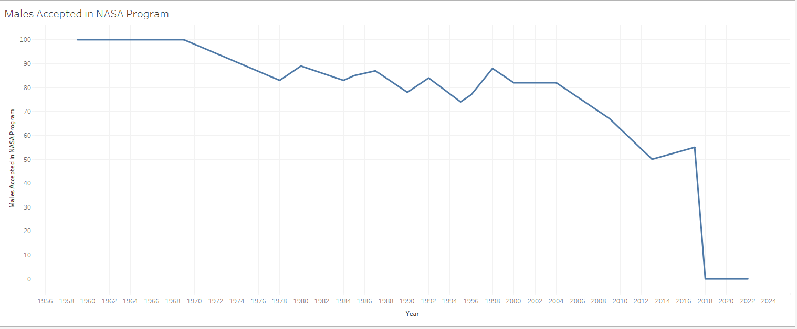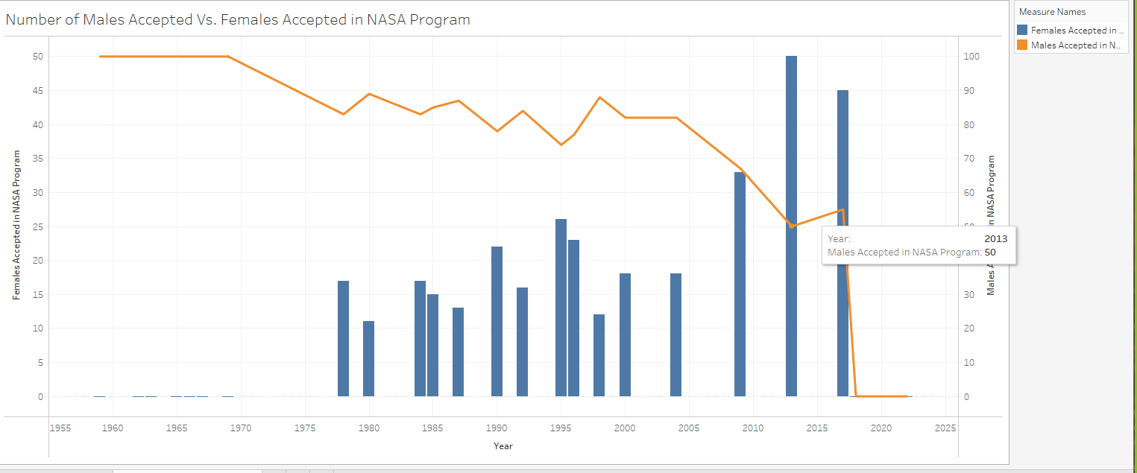

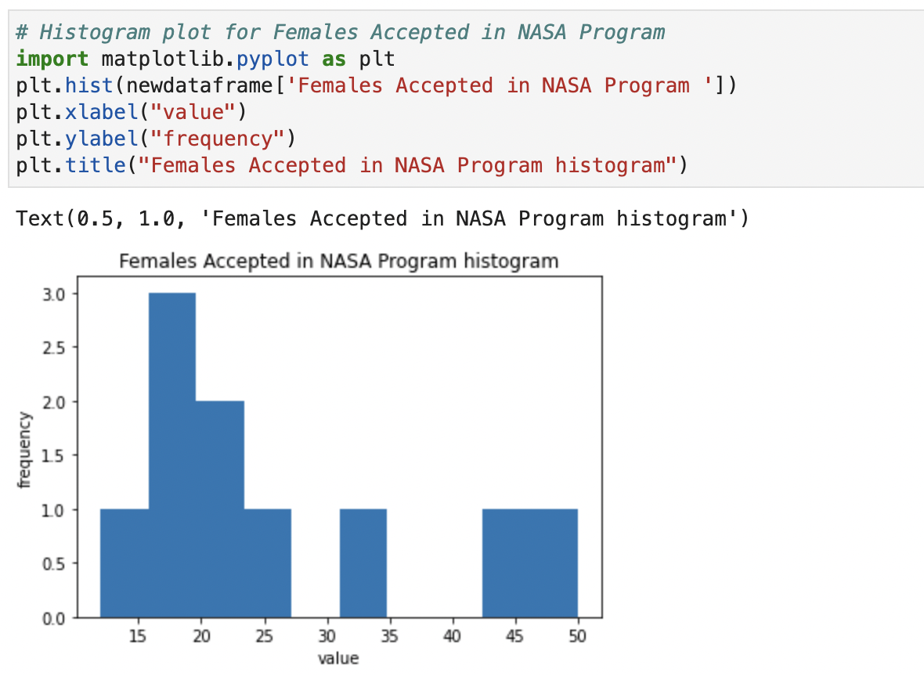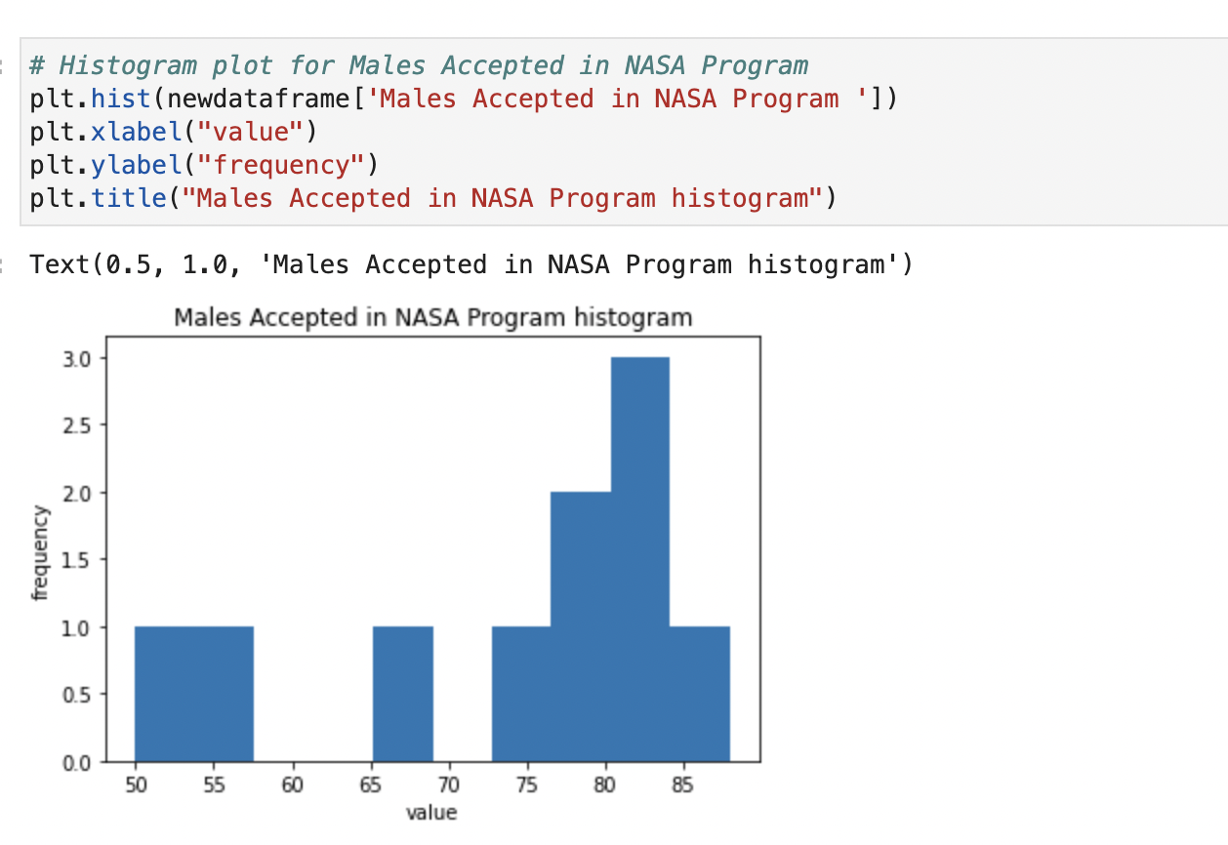

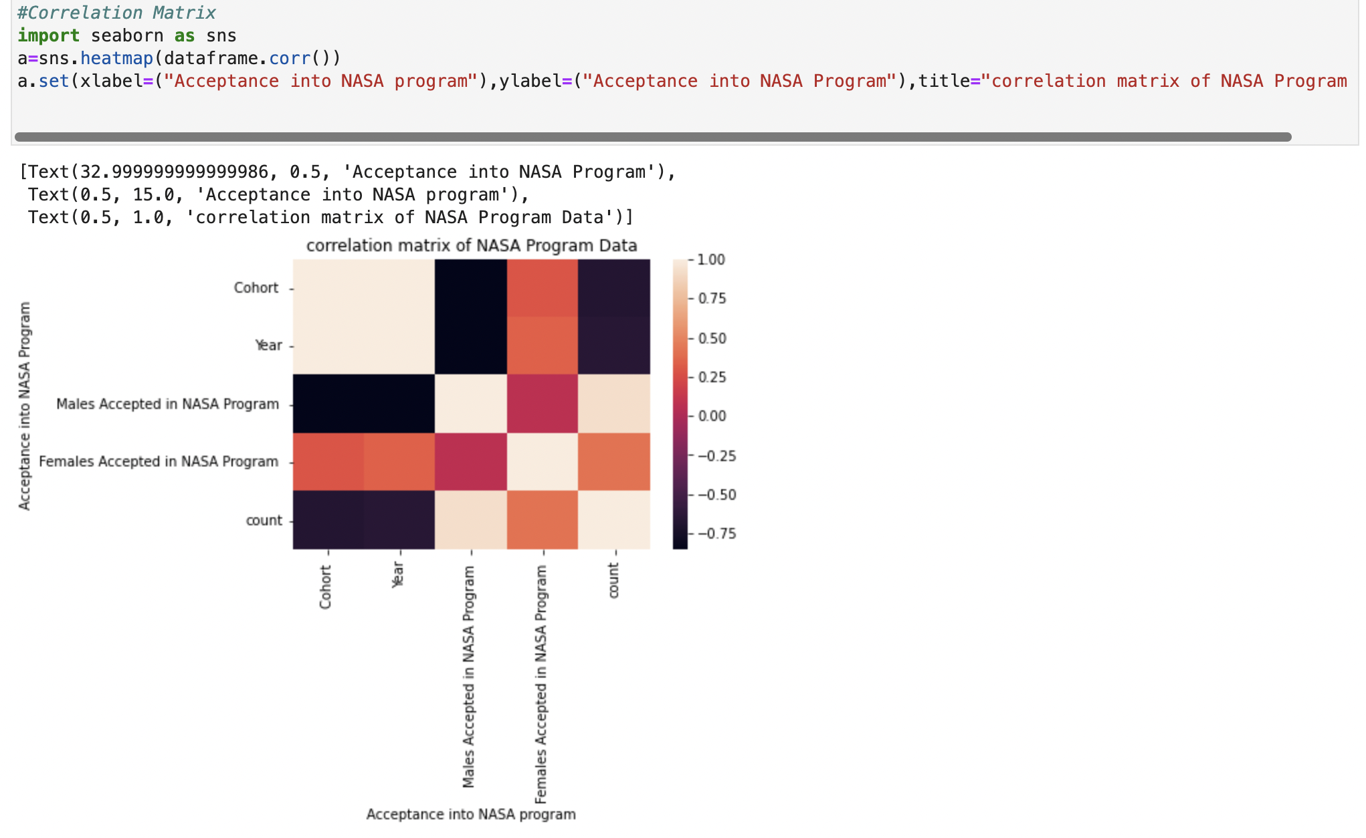

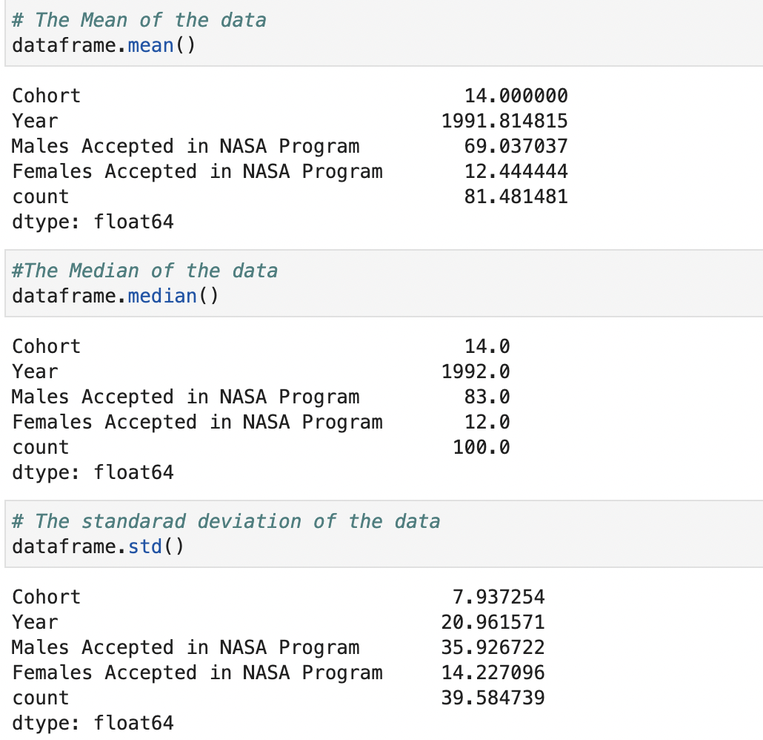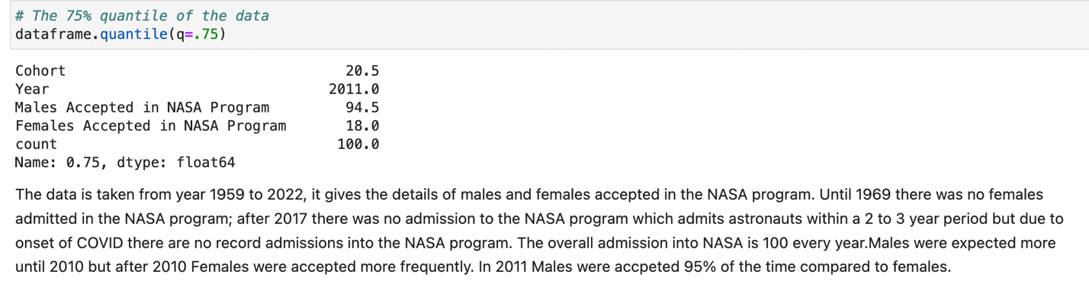

* Kendra Sawyer

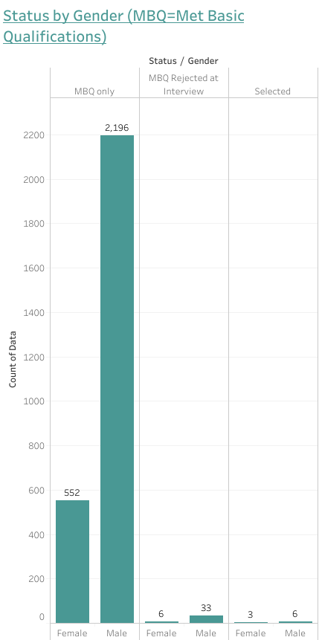

* Cynthia Cardenas

What gender and race gets the most space flight hours?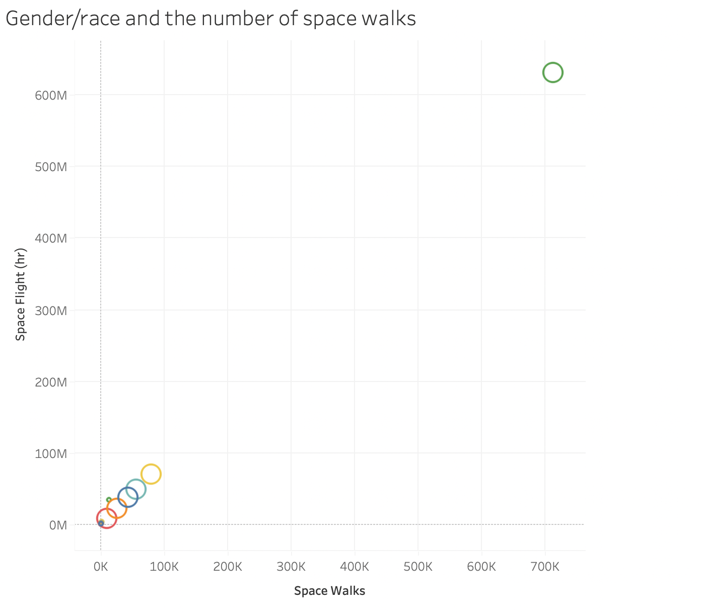

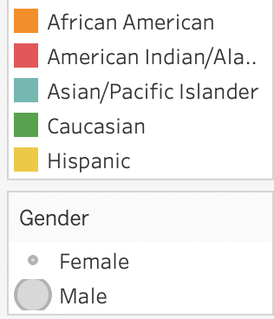

After doing this tableau graph I was able to determine that Caucasian males have significantly more space flight time than anyone else.

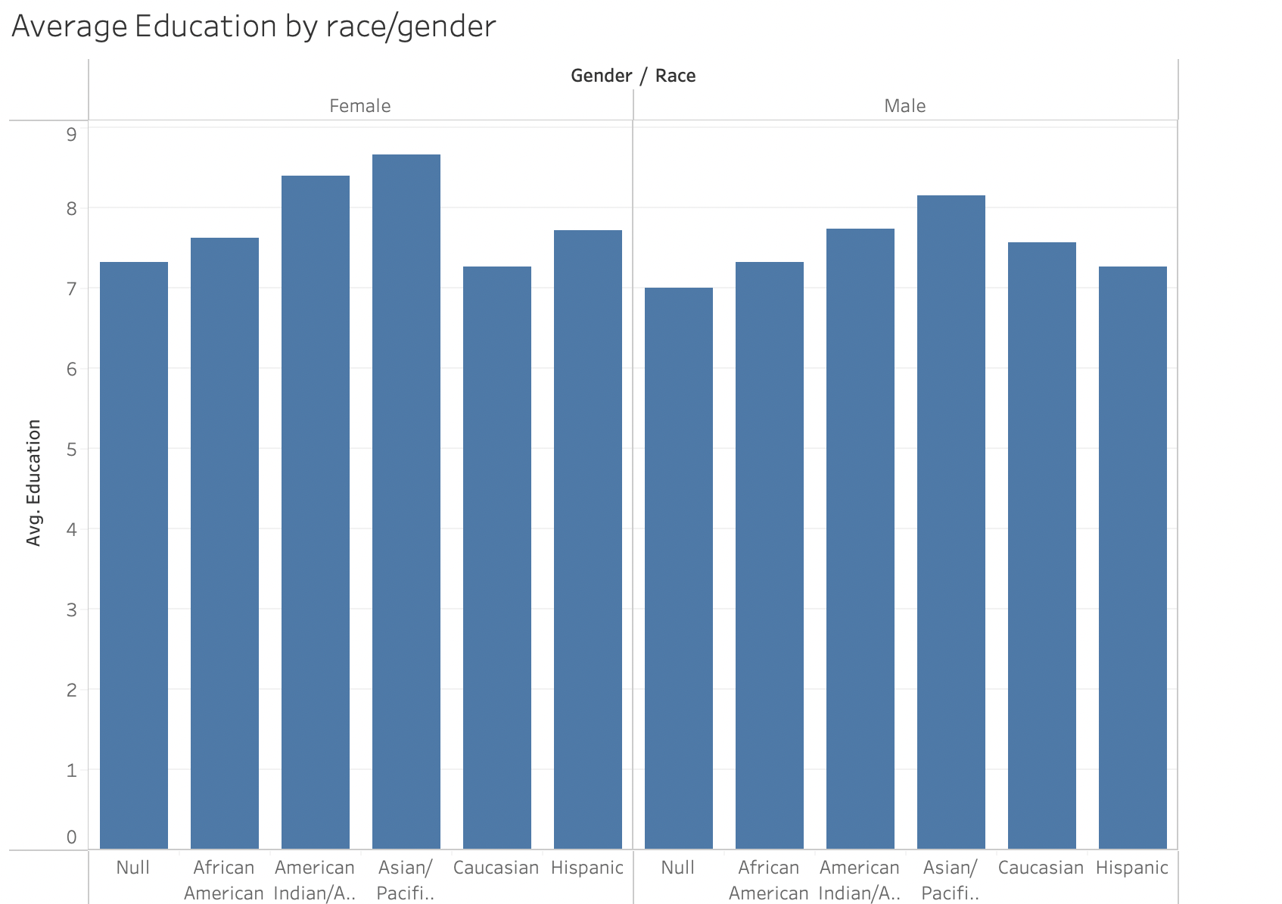In this graph I wanted to see if there was a discrepancy between the about of education between male and female as well as race. Just by looking at the graph I can tell overall, females tend to have more years of education with Asian females having the most education.

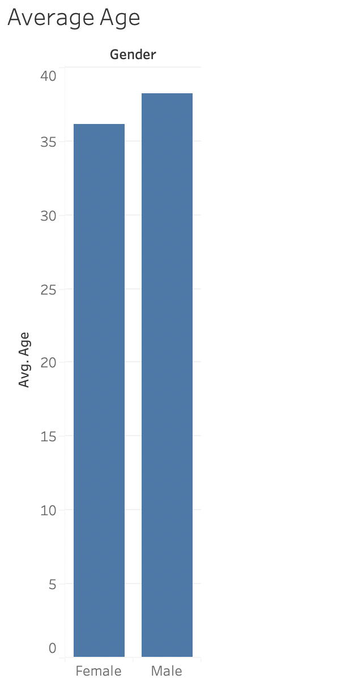Here I was able to determine that on average male Astronauts tend to be older than their female counter parts.

